|  |  |
| --- | --- |
| Contact Details Narrogin Senior High School | **NARROGIN SENIOR HIGH SCHOOL**  **Mathematics Methods Units 3 & 4**  **Test 4- 2021 Normal Distribution, Random Sampling and sample proportion** |

**Calculator Free Section**

Time: 27 minutes

Total Marks: ______ / 23 marks

Resources allowed: SCSA Formula Sheet

**Instructions to candidates**

Show all your working clearly. Your working should be in sufficient detail to allow your answers to be checked readily and for marks to be awarded for reasoning. Incorrect answers given without supporting reasoning cannot be allocated any marks**. For any question or part question worth more than two marks, valid working or justification is required to receive full marks.** If you repeat any question, ensure that you cancel the answer you do not wish to have marked.

Question 1. [2,2 = 4 marks]

**a)** Under what two circumstances can you assume that the distribution of sample proportions of a distribution $X$ is normally distributed?

**b)** If $X$ has mean $μ=27$ and standard deviation $=3.25$ **,** what are the mean and standard deviations of the distribution of 64 sample proportions?

**Question 2 [1, 3, 3 = 7 marks]**.

The amount of granulated coffee dispensed to make a cup of coffee is uniformly distributed from 4.5g to 5.5g.

**a)** State the probability that in any cup of coffee produced by this coffee machine that the mass of granulated coffee used is more than 5.4g

The machine was used 36 times and the proportion of times more than 5.4 g of granulated coffee was dispensed was recorded. This was repeated 100 times so that a collection of 100 sample proportions was obtained.

**b)** Describe the sampling distribution of sample proportions of size 36 for the mass of granulated coffee dispensed exceeding 5.4g, stating its mean and standard deviation.

**c)** Describe the frequency distribution of the 100 sample proportions of the mass of granulated coffee used exceeding 5.4g, stating its mean and standard deviation.

**Question 3 [ 1, 1,2, 2 = 7 marks]**

A student planned to investigate what proportion of the 1260 students at their school had access to more than one computer at home.

**a)** The student thought of the following three ways to select a sample from the population. Briefly discuss the main source of bias in each method.

**i)** Wait at the bus-bay after school and ask the first 50 students who show up.

**ii)** Select and ask every 100th student from the school roll.

**b)** Assuming that 80% of students had access to more than one computer at home, the student carried out 100 simulations in which a sample proportion was calculated from a random sample of 64 students.

(i) Explain why it is reasonable to expect that the distribution of the sample proportions would approximate normality.

(ii) Determine the mean and standard deviation of the normal distribution that the sample proportions would approximate.

Question 4 [ 1,2,2 = 5 marks]

The following graph is of a **continuous** random variable, *X*.

*k*

***x***

0 1 2 3 4 5

*f(x)*

**a)** State the value of *k.*

**b)** Complete the description of the probability

density function

**c)** State:

1. P(*X* < 3)

Ii) P(*X* < 3 | *X* > 1)

|  |  |
| --- | --- |
| Contact Details Narrogin Senior High School | **NARROGIN SENIOR HIGH SCHOOL**  **Mathematics Methods Units 3 & 4**  **Test 4- 2021 CRV, Random Sampling and sample proportion** |

Name: _____________________________

**Calculator Assumed Section**

Time: 30 minutes

Total Marks: ______ / 26 marks

Resources allowed:

SCSA Formula Sheet

Up to three Calculators and

One A4 sheet, both sides of notes

**Instructions to candidates**

Show all your working clearly. Your working should be in sufficient detail to allow your answers to be checked readily and for marks to be awarded for reasoning. Incorrect answers given without supporting reasoning cannot be allocated any marks. **For any question or part question worth more than two marks, valid working or justification is required to receive full marks.** If you repeat any question, ensure that you cancel the answer you do not wish to have marked.

|  |  |
| --- | --- |
| **Question 5 [3, 2, = 5 marks]** |  |

A random variable Y has a mean of μ and a standard deviation of 2.4. 200 sample trials of Y were recorded and the mean was y = 6.3 .

1. State the probability distribution for the sampling distribution of Y and explain your answer.

1. Calculate a 95% confidence interval for μ

**Question 7 [2, 4 = 7 marks]**

1. A random sample of Year 12 students was undertaken from which the 90% confidence interval for the proportion of students who planned to take a gap year after finishing Year 12 was determined to be (0.034, 0.252).
2. Explain why the reliability of this interval estimate is not immediately evident.
3. Determine the corresponding 95% confidence interval based on this survey.

Question 8 **[4, 1, 4 = 9 marks]**

The probability of occurrence of a given property is  The simulation of five samples, each of size 50, was conducted, and the mean of each sample is given below.

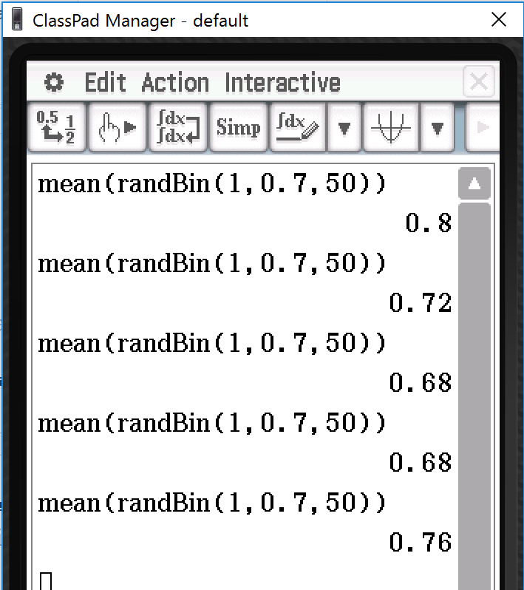

1. Calculate 90% confidence interval for the first sample.
2. Hence comment on the position of p in this confidence interval.
3. Repeat (a) and (b) for the fourth simulation

Question 9 **[3,2,5 = 10 marks]**

The number of fans accessing the Perth Glory official website each day is modelled

by a normal random variable with a mean of 350 and standard deviation of 18.

**a)** Determine the probability that tomorrow there will be:

**i)** fewer than 340 hits on the website

**ii)** fewer than 370, given that there are more than 340.

**b)** Determine the probability that over the next 5 days there will be between 340 and 370 on exactly 3 of those days. Show all distributions and relevant parameters that you use.

**c)** Using the normal approximation to the binomial distribution, determine the probability that over the next 365 days, there will be between 340 and 370 people on fewer than 200 occasions.

Question 10 **[ 5,1,2,2,3 = 13 marks]**

The fat content (in grams) of 30 randomly selected pasties at a local Greenwood bakery was recorded:

15.1 14.8 13.7 15.6 15.1 16.1 16.6 17.4 16.1 13.9

17.5 15.7 16.2 16.6 15.1 12.9 17.4 16.5 13.2 14.0

17.2 17.3 16.1 16.5 16.7 16.8 17.2 17.6 17.3 14.8

**a)** Determine a 90% confidence interval for the mean fat content of all pasties made at this bakery.

**b)** Make a summary statement of your findings in part **a)**.

**c)** What would be the equivalent 95% confidence interval in this situation?

**d)** Compare the margins of error in both instances.

**e)** What sample size would be required to maintain a margin of error of 0.3g with a 95% confidence interval?